**Adventure Works Database**

**Description:**

Adventure Works Cycles, the company on which the AdventureWorks sample databases are based, is a large, multinational manufacturing company. The company manufactures and sells metal and composite bicycles to North American, European and Asian commercial markets. While its base operation is in Bothell, Washington with 290 employees, several regional sales teams are located throughout their market base.

In 2000, Adventure Works Cycles bought a small manufacturing plant, Importadores Neptuno, located in Mexico. Importadores Neptuno manufactures several critical subcomponents for the Adventure Works Cycles product line. These subcomponents are shipped to the Bothell location for final product assembly. In 2001, Importadores Neptuno, became the sole manufacturer and distributor of the touring bicycle product group.

Coming off a successful fiscal year, Adventure Works Cycles is looking to broaden its market share by targeting their sales to their best customers, extending their product availability through an external Web site, and reducing their cost of sales through lower production costs.

**Includes Data for:**

* Sales
* Person
* Production
* Purchasing
* Human Resource

**Database Schema:**

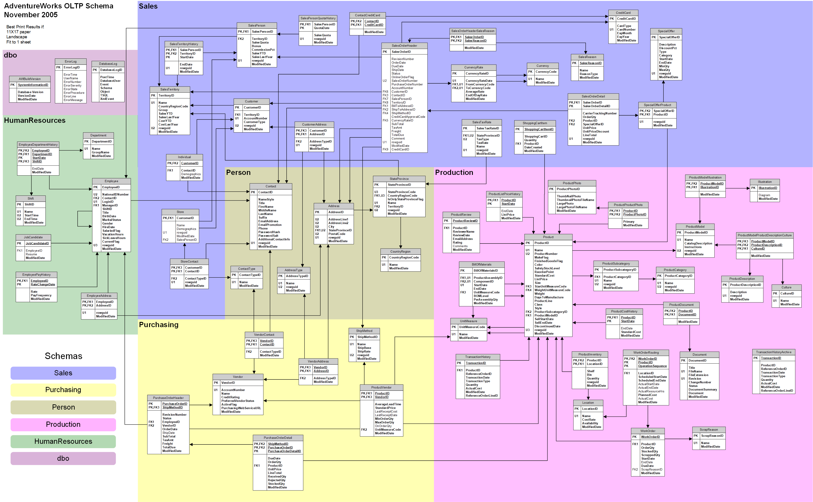

**Note:**

The data warehouse is huge. I am just focusing on internet sales related questions.

**Business Questions:**

* Total online sales
* Percentage Sales by Country
* Sales by different sates of countries
* Sales by Year
* Sales by product category
* Sales by product Sub-category
* Units sold by year
* Top products in term of sales

**Tools:**

I am using SQL Server for data warehouse. And Tableau for data visualization.

**Dashboard:**

It would have map, bar charts, pie chart, tree map, total sales KPI and a couple of filters.

--- End ---